**Assignment - 05**

**Team members:**

**Mahitha Gurrala(U19CS066)**

**Krithikha Balamurugan (U19CS076)**

**Guntuboina Venkata Sankirtana (U19CS068)**



1.1 Find a computational problem that you can solve using the divide and conquer approach. The problem should be different from the problems discussed in class,and it should be unique and interesting.

PROBLEM STATEMENT: TO FIND A PEAK IN THE 2D ARRAY

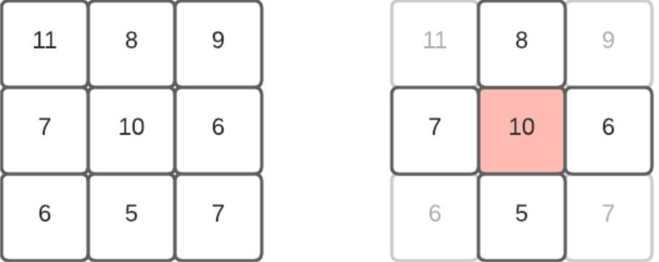

A peak element is defined as -

An element is greater than or equal to its four neighbors, **left, right, top and bottom**. For example neighbors for A[i][j] are A[i-1][j], A[i+1][j], A[i][j-1] and A[i][j+1],then the element is called a **peak element**.

The side elements are considered accordingly for their neighbours.

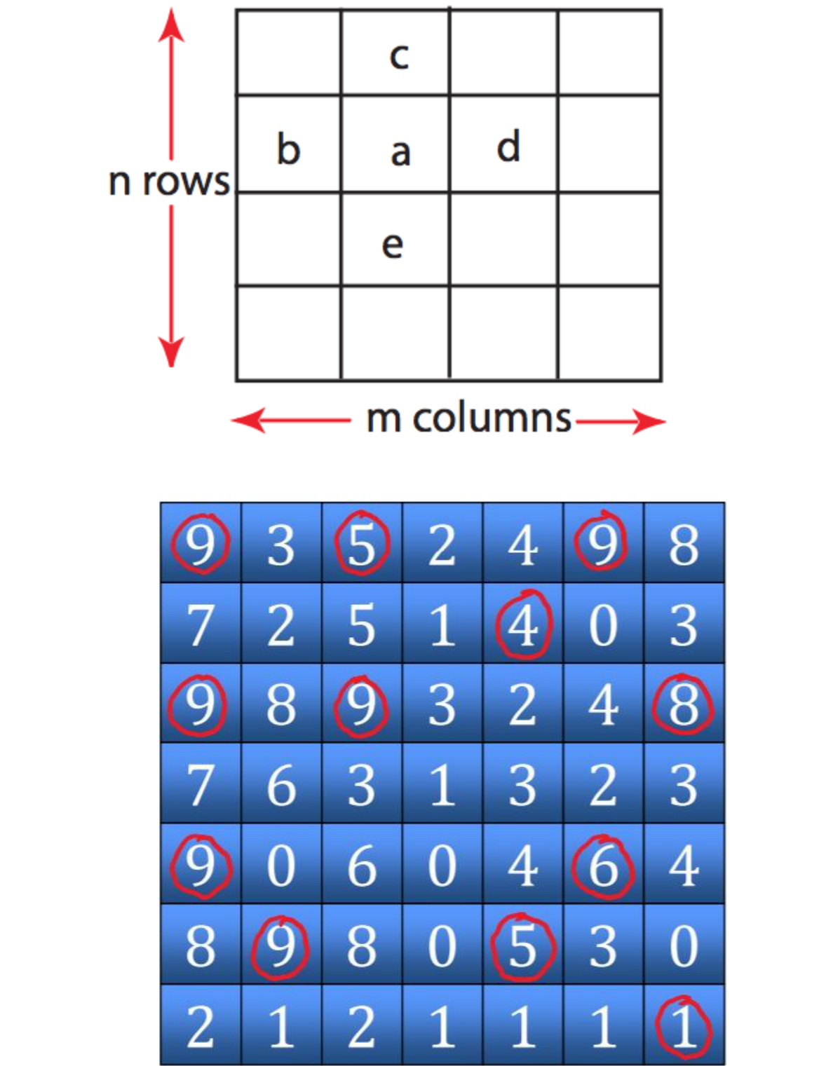

1.2 Write pseudocodes to design algorithms for the above mentioned computational problem using the brute-force approach (incremental approach) and the divide and conquer approach.

Brute force:

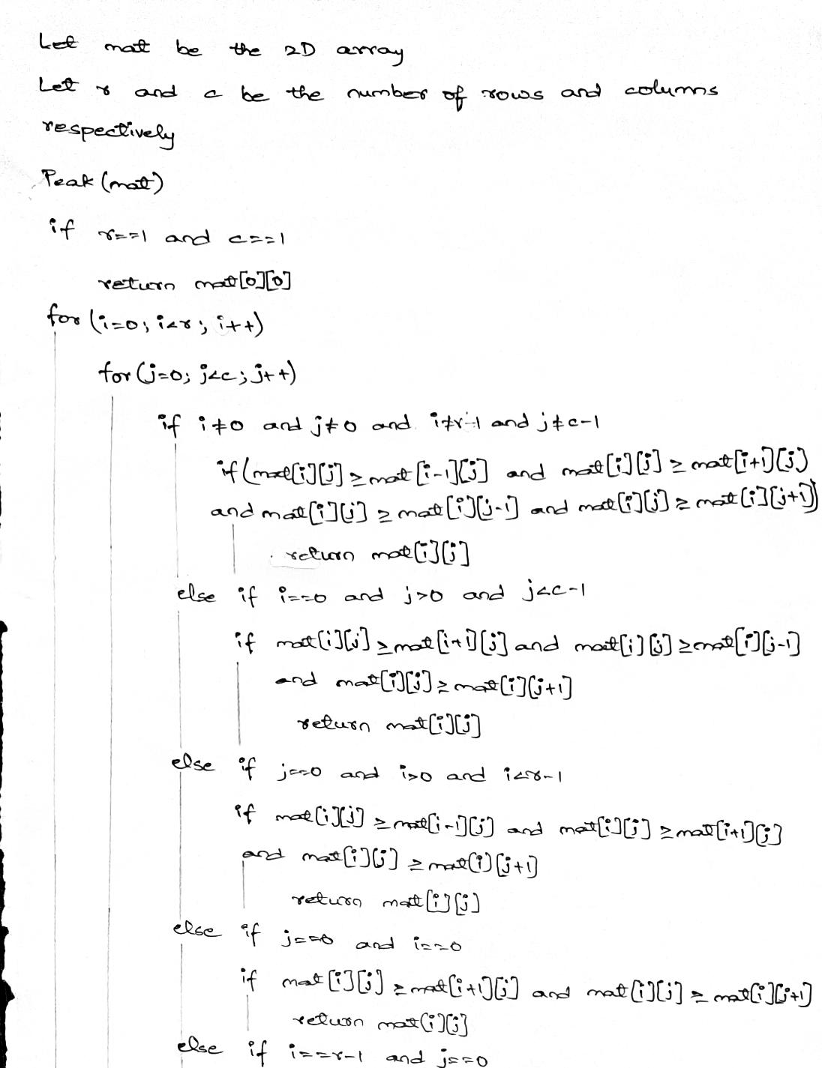

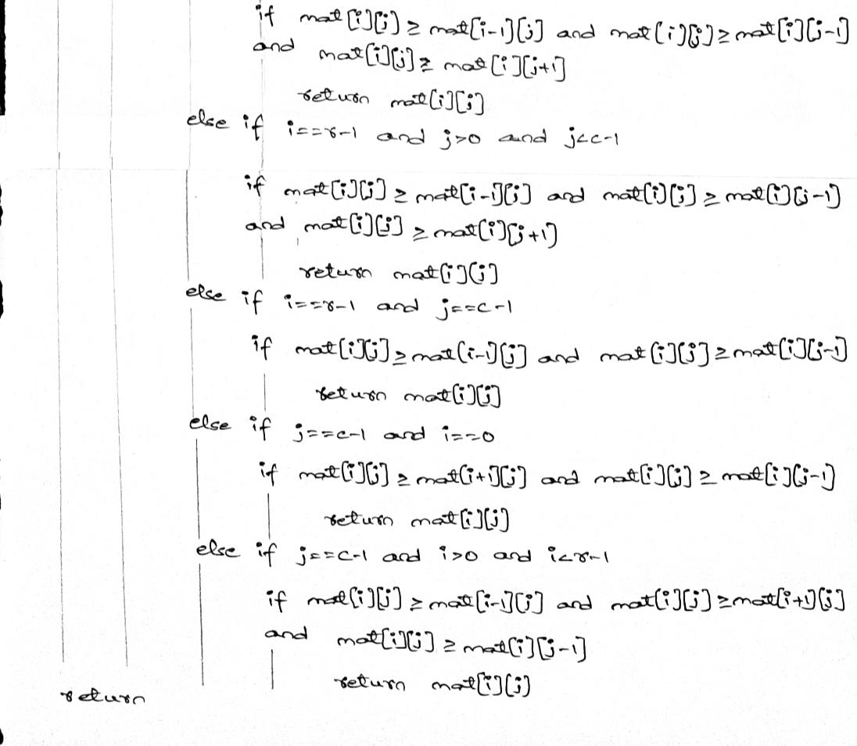

Divide and conquer:

EFFICIENT ALGORITHM APPROACH EXPLAINED-

* Pick middle column j = m/2
* Find global maximum on column j at (i, j)
* Compare (i, j − 1),(i, j),(i, j + 1)
* Pick left columns of (i, j − 1) > (i, j)
* Similarly for right
* (i, j) is a 2D-peak if neither condition holds
* Solve the new problem with half the number of columns.
* When you have a single column, find global maximum and you‘re done.

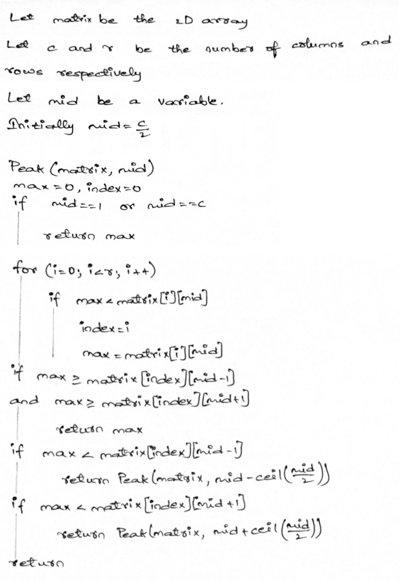

1.3 Analyze the time complexity of above algorithms. Analyze the divide and conquer algorithm using different methods such as (1) Recursion Tree Method (2) Iterative Method (3) Master Method (4) Substitution Method. Try to analyze the algorithm using as many methods as discussed above.

ITERATIVE

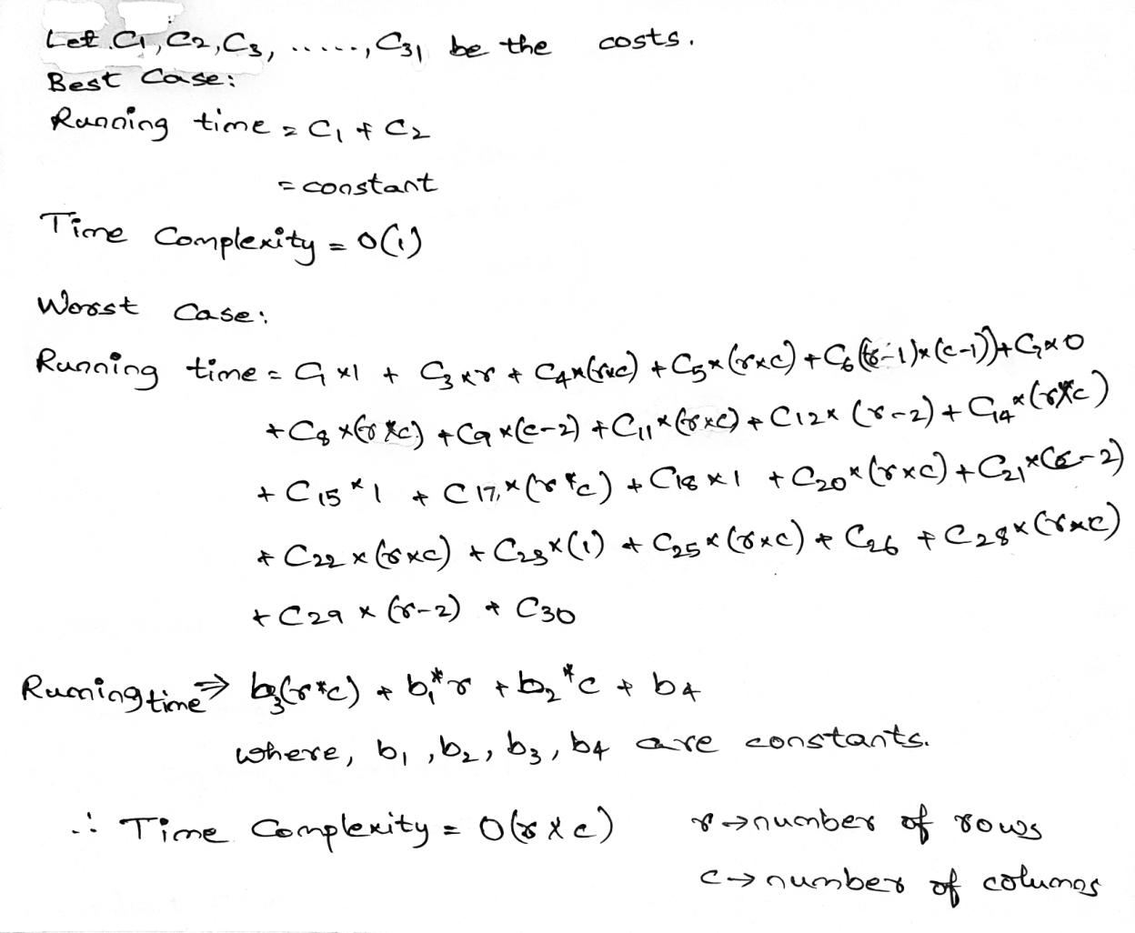

SUBSTITUTION

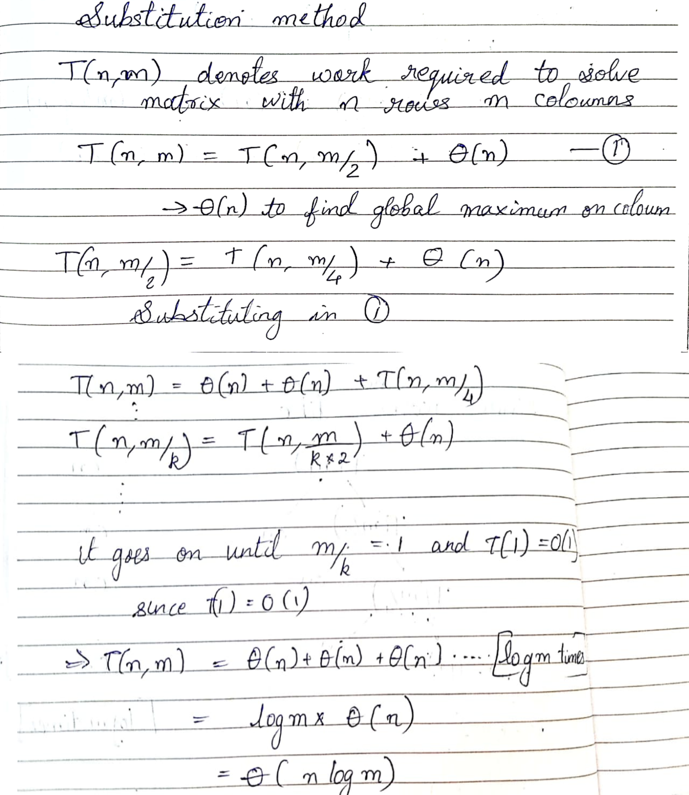

RECURSION TREE

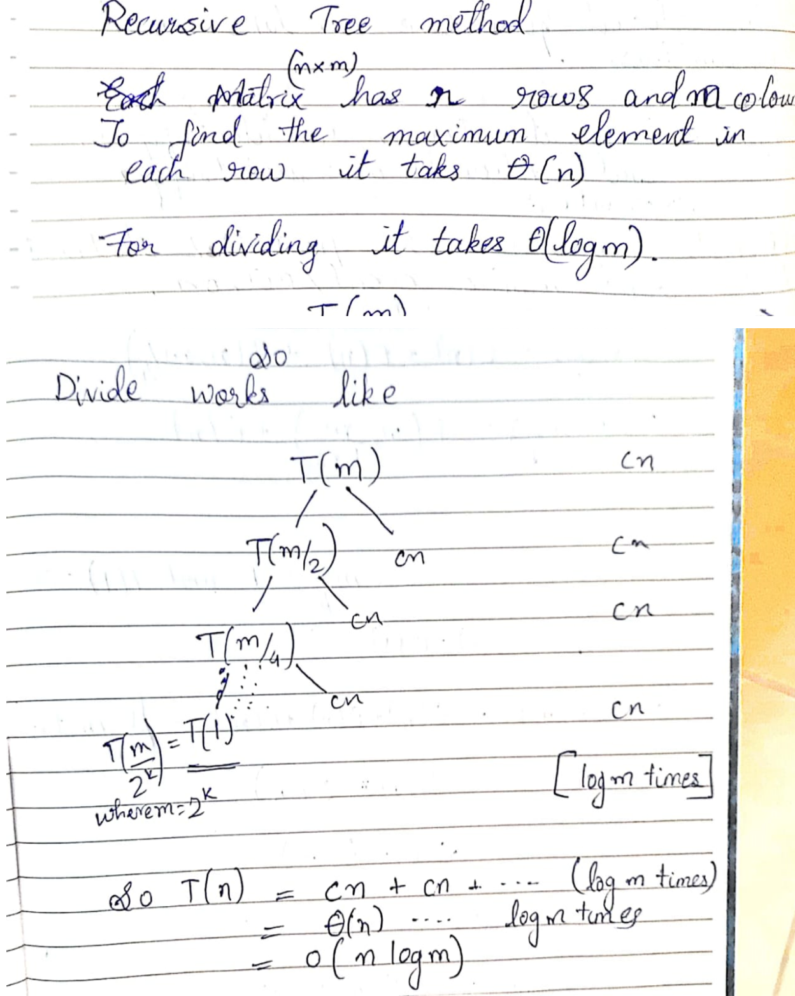

MASTER METHOD

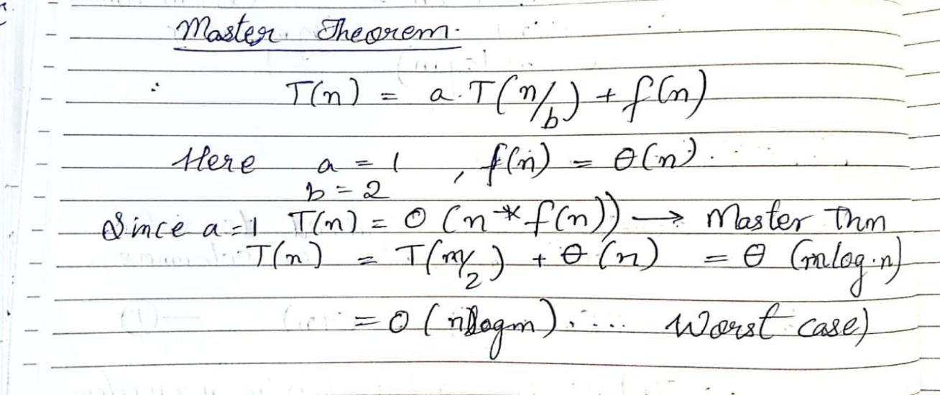

1.4 Provide the details of Hardware/Software you used to implement algorithms and to measure the time.

|  |  |  |
| --- | --- | --- |
| Compiler | Dev C++ 5.11 |  |
| OS Name | Microsoft Windows 10 Home (i5 8th Gen) | |
| Version | 10.0.19042 Build 19042 | |
| System Name | DESKTOP-BLE6CMQ | |
| System Model | HP Pavilion x360 Convertible 14-ba1xx | |
| System Type | x64-based PC | |
| Processor | Intel(R) Core(TM) i5-8250U CPU @ 1.60GHz, 1800 | |
|  | Mhz, 4 Core(s), 8 Logical Processor(s) | |
| BIOS Version/Date | Insyde F.54, 04-12-2019 | |
| Installed Physical Memory (RAM) | | 8.00 GB |
| Total Physical Memory |  | 7.88 GB |
| Available Physical Memory | | 1.75 GB |
| Total Virtual Memory |  | 12.4 GB |
| Available Virtual Memory |  | 4.59 GB |
| Page File Space |  | 4.50 GB |

1.5 Implement the above algorithms and submit the code (complete programs).

ITERATIVE APPROACH-

**#include <bits/stdc++.h>**

**#include <time.h>**

**using namespace std;**

**clock_t begin, end;**

**double time_;**

**int** matrix_allocate(int n,int m)**

**{**

**int i, j;**

**int** mat = (int** ) malloc(n * sizeof(int* ));**

**for (i = 0; i < n; ++i)**

**{**

**mat[i] = (int* )malloc(m * sizeof(int));**

**}**

**return mat;**

**}**

**int Peak(int **mat, int r,int c)**

**{**

**if (r == 1&&c==1)**

**{**

**return mat[0][0];**

**}**

**for (int i = 0; i <r; i++)**

**{**

**for(int j=0;j<c;j++)**

**{**

**if(j==0 && i==0)**

**{**

**if (mat[i][j] >= mat[i+1][j] && mat[i][j] >= mat[i][j+1])**

**{**

**return mat[i][j];**

**}**

**}**

**else if(i==0 && j>0 && j<c-1)**

**{**

**if (mat[i][j] >= mat[i+1][j]&&mat[i][j] >= mat[i][j-1]**

* **mat[i][j] >= mat[i][j+1])**

**{**

**return mat[i][j];**

**}**

**}**

**else if(j==0 && i>0 && i<r-1)**

**{**

**if (mat[i][j] >= mat[i-1][j] && mat[i][j] >= mat[i+1][j] && mat[i][j] >= mat[i][j+1])**

**{**

**return mat[i][j];**

**}**

**}**

**else if(i==r-1 && j==0)**

**{**

**if (mat[i][j] >= mat[i-1][j] && mat[i][j] >= mat[i][j-1] && mat[i][j] >= mat[i][j+1])**

**{**

**return mat[i][j];**

**}**

**}**

**else if(i==r-1&& j>0 && j<c-1)**

**{**

**if (mat[i][j] >= mat[i-1][j] &&mat[i][j] >= mat[i][j-1] && mat[i][j] >= mat[i][j+1])**

**{**

**return mat[i][j];**

**}**

**}**

**else if(i==r-1 &&** **j==c-1)**

**{**

**if (mat[i][j] >= mat[i-1][j] && mat[i][j] >= mat[i][j-1])**

**{**

**return mat[i][j];**

**}**

**}**

**else if(j==c-1 && i==0)**

**{**

**if (mat[i][j] >= mat[i+1][j]&&mat[i][j] >= mat[i][j-1])**

**{**

**return mat[i][j];**

**}**

**}**

**else if(j==c-1 && i>0 && i<r-1)**

**{**

**if (mat[i][j] >= mat[i-1][j] && mat[i][j] >= mat[i+1][j]&&mat[i][j] >= mat[i][j-1])**

**{**

**return mat[i][j];**

**}**

**}**

**else**

**{**

**if (mat[i][j] >= mat[i-1][j] && mat[i][j] >= mat[i+1][j]&&mat[i][j] >= mat[i][j-1] && mat[i][j] >= mat[i][j+1])**

**{**

**return mat[i][j];**

**}**

**}**

**}**

**}**

**}**

**int main()**

**{**

**int r,c;**

**printf("Enter rows and columns:");**

**cin>>r>>c;**

**int** mat = matrix_allocate(r,c);**

**printf("\nEnter matrix elements:");**

**for(int i=0;i<r;i++)**

**{**

**for(int j=0;j<c;j++)**

**{**

**cin>>mat[i][j];**

**cout<<mat[i][j];**

**}**

**}**

**int mid=c/2;**

**begin = clock();**

**cout << "\n\nFirst Peak element is : "<<Peak(mat, r, c); end = clock();**

**time_= ((double)(end-begin)) / CLOCKS_PER_SEC; cout<<"\nTime taken :"<<time_;**

**return 0;**

**}**

DIVIDE AND CONQUER APPROACH-

**#include <bits/stdc++.h>**

**#include <time.h>**

**#define MAX 1000**

**using namespace std;**

**clock_t begin, end;**

**double time_;**

**int** matrix_allocate(int n,int m)**

**{**

**int i, j;**

**int** mat = (int** ) malloc(n * sizeof(int* ));**

**for (i = 0; i < n; ++i)**

**{**

**mat[i] = (int* ) malloc(m * sizeof(int));**

**}**

**return mat;**

**}**

**int Peak(int **mat, int r, int c, int mid)**

**{**

**int max = 0;**

**int ind=0;**

**for (int i = 0; i < r; i++)**

**{**

**if (max < mat[i][mid])**

**{**

**max = mat[i][mid];**

**ind = i;**

**}**

**}**

**if (mid == 0 || mid == c - 1)**

**return max;**

**if (max >= mat[ind][mid - 1] && max >= mat[ind][mid + 1])**

**return max;**

* **If max is less than its left if (max < mat[ind][mid - 1])**

**return Peak(mat, r, c, mid + ceil((double)mid / 2));**

**// if (max < mat[ind][mid+1])** **//If max is less than its right**

**return Peak(mat, r, c, mid + ceil((double)mid / 2));**

**}**

**int main()**

**{**

**int r,c;**

**printf("Enter rows and columns:");**

**cin>>r>>c;**

**int** mat = matrix_allocate(r,c);**

**printf("\nEnter matrix elements:");**

**for(int i=0;i<r;i++)**

**{**

**for(int j=0;j<c;j++)**

**{**

**cin>>mat[i][j];**

**}**

**}**

**int mid=c/2;**

**begin = clock();**

**cout << "\n\nFirst Peak element is : "<<Peak(mat, r, c,mid); end = clock();**

**time_= ((double)(end-begin)) / CLOCKS_PER_SEC; cout<<"\nTime taken :"<<time_;**

**return 0;**

**}**

1.6 Analyze the performance of both the implemented algorithms (performance of algorithms on your computers). Plot a graph.

DIVIDE AND CONQUER

|  |  |
| --- | --- |
| **N** | **Divide Conquer** |
|  |  |
| 10 | 0.002 |
|  |  |
| 50 | 0.008 |
|  |  |
| 100 | 0.02 |
|  |  |
| 500 | 0.13 |
|  |  |
| 1000 | 0.32 |
|  |  |
| 2000 | 0.63 |
|  |  |

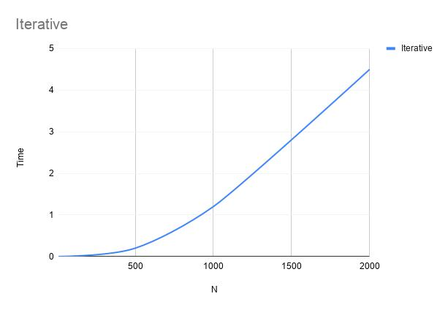

ITERATION METHOD

|  |  |
| --- | --- |
| **N** | **Iterative** |
|  |  |
| 10 | 0 |
|  |  |
| 50 | 0.002 |
|  |  |
| 100 | 0.01 |
|  |  |
| 500 | 0.2 |
|  |  |
| 1000 | 1.2 |
|  |  |
| 2000 | 4.9 |
|  |  |

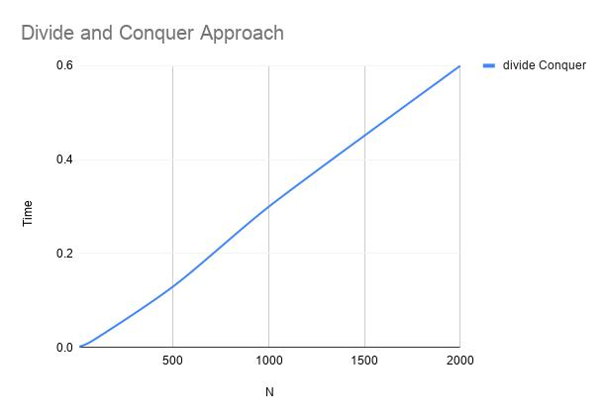

1.7 Comparatively analyze the performance of above algorithms and plot a graph.

For simplicity we have taken only square matrices where n depicts the number of rows and columns.

|  |  |  |
| --- | --- | --- |
| **N** | **Divide Conquer** | **Iterative** |
|  |  |  |
| 10 | 0.002 | 0 |
|  |  |  |
| 50 | 0.008 | 0.002 |
|  |  |  |
| 100 | 0.02 | 0.01 |
|  |  |  |
| 500 | 0.13 | 0.2 |
|  |  |  |
| 1000 | 0.32 | 1.2 |
|  |  |  |
| 2000 | 0.63 | 4.9 |
|  |  |  |

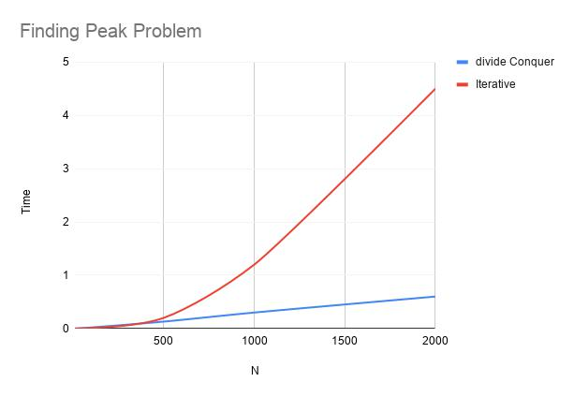

TIME COMPLEXITY

USING DIVIDE AND CONQUER: O(n*log(m))

USING ITERATION METHOD: O(n*m)



n → number of rows

m → number of columns

APPLICATIONS

* One of the common challenges in signal processing is to detect important points in time or in space like peaks. These points represent local maxima (or minima)

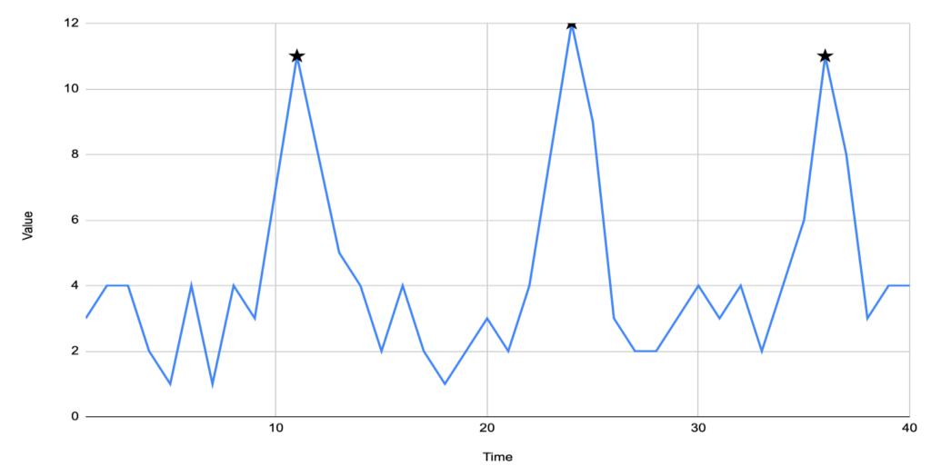

* **The noise is a general term of unwanted modifications of the signal**. Let’sconsider the example of our infrared camera. If we happen to point it to a white wall, our image would be homogeneous but due to the noise, there could be many pixel positions labeled as a peak if we take only the definition above.

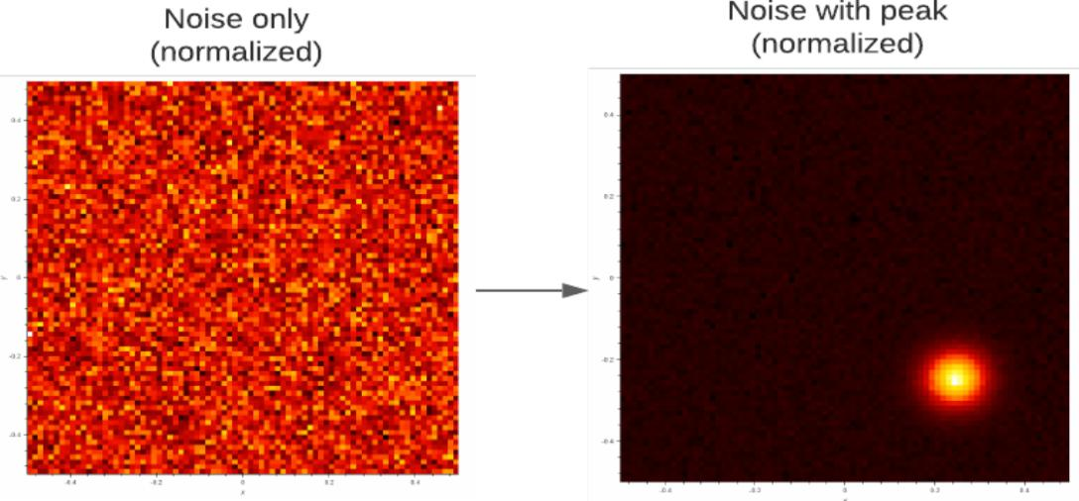

* In special cases, more sophisticated algorithms are known and used like the [Genetic algorithm](https://www.baeldung.com/java-genetic-algorithm) or the famous optimization method [Gradient Descent](https://www.baeldung.com/java-gradient-descent). They are appreciated mainly in scientific applications for instance